INFO 7290 (DWBI): HW04b - SQL

Smit Patil

-- 01 Find the employees hired in the last 365 days of the data set. Determine the last 365 days with a query. List first and last name along with department.

SELECT FirstName,

LastName,

HireDate,

d.Name AS DepartmentName,

d.GroupName

FROM Person.Person p

JOIN HumanResources.Employee e ON p.BusinessEntityID = e.BusinessEntityID

JOIN HumanResources.EmployeeDepartmentHistory edh ON e.BusinessEntityID = edh.BusinessEntityID

JOIN HumanResources.Department d ON edh.DepartmentID = d.DepartmentID

WHERE HireDate BETWEEN DATEADD(DAY, -365, (SELECT MAX(HireDate) FROM HumanResources.Employee))

AND (SELECT MAX(HireDate) FROM HumanResources.Employee)

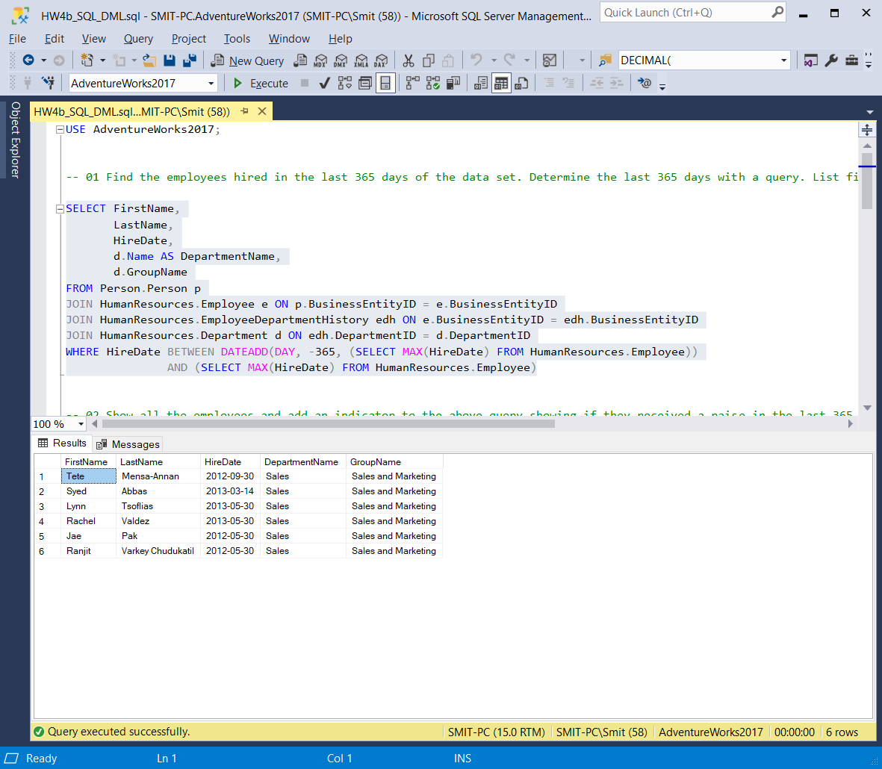

-- 02 Show all the employees and add an indicator to the above query showing if they received a raise in the last 365 days.

SELECT FirstName,

LastName,

Rate,

HireDate,

CAST(RateChangeDate AS DATE) AS RateChangeDate,

CASE WHEN RateChangeDate > HireDate THEN 1 ELSE 0 END AS RateFlag

FROM Person.Person p

JOIN HumanResources.Employee e ON p.BusinessEntityID = e.BusinessEntityID

JOIN HumanResources.EmployeePayHistory eph ON e.BusinessEntityID = eph.BusinessEntityID

WHERE RateChangeDate BETWEEN DATEADD(DAY, -365, (SELECT MAX(HireDate) FROM HumanResources.Employee))

AND (SELECT MAX(HireDate) FROM HumanResources.Employee)

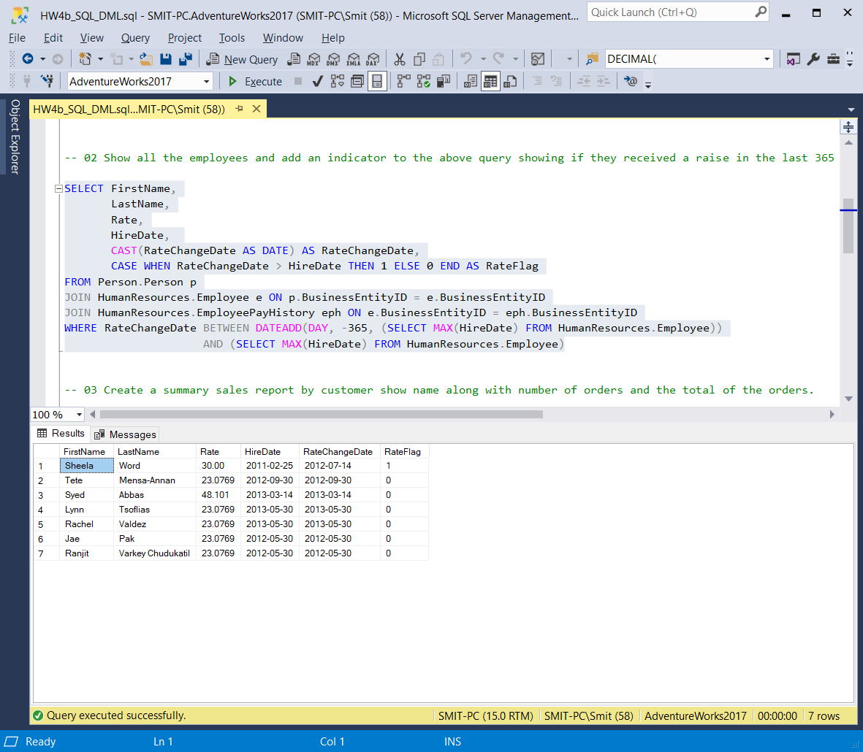

-- 03 Create a summary sales report by customer show name along with number of orders and the total of the orders.

SELECT CONCAT(FirstName, ' ',MiddleName, ' ',LastName) AS Name,

COUNT(SalesOrderNumber) AS NumberOfOrders,

SUM(OrderQty) AS TotalOrderQty,

SUM(SubTotal) AS SubTotal,

SUM(TaxAmt) AS TaxAmount,

SUM(Freight) AS Freight,

SUM(TotalDue) AS TotalDue

FROM Sales.Customer c

JOIN Person.Person p ON c.PersonID = p.BusinessEntityID

JOIN Sales.SalesOrderHeader soh ON c.CustomerID = soh.CustomerID

JOIN Sales.SalesOrderDetail sod ON soh.SalesOrderID = sod.SalesOrderID

GROUP BY FirstName, MiddleName, LastName

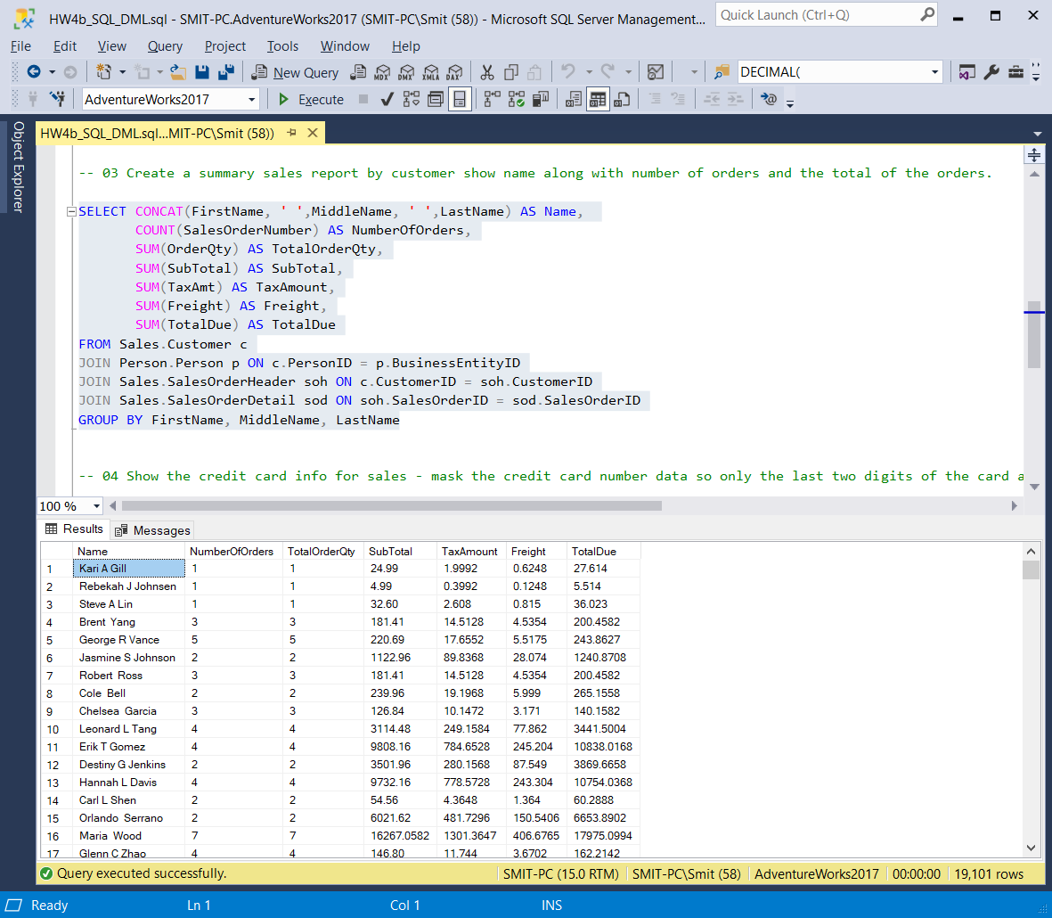

-- 04 Show the credit card info for sales - mask the credit card number data so only the last two digits of the card are visible. For example, 123456 would be \*\*\*\*56

SELECT SalesOrderNumber,

CONCAT(FirstName, ' ',MiddleName, ' ',LastName) AS Name,

CardType,

STUFF(CardNumber, 1, 12, '\*\*\*\*\*\*\*\*\*\*\*\*') AS CardNumber,

ExpMonth,

ExpYear,

TotalDue

FROM Sales.Customer c

JOIN Person.Person p ON c.PersonID = p.BusinessEntityID

JOIN Sales.SalesOrderHeader soh ON c.CustomerID = soh.CustomerID

JOIN Sales.CreditCard cc ON soh.CreditCardID = cc.CreditCardID

